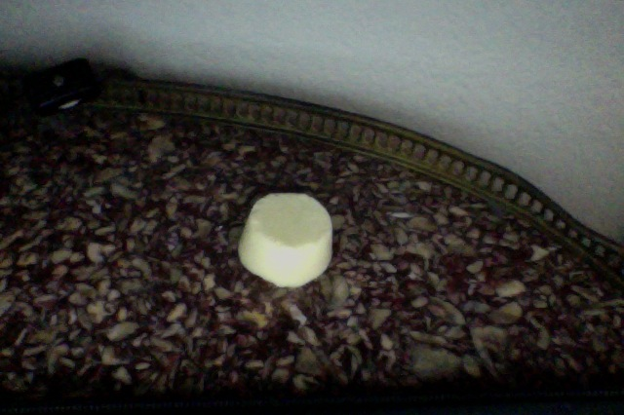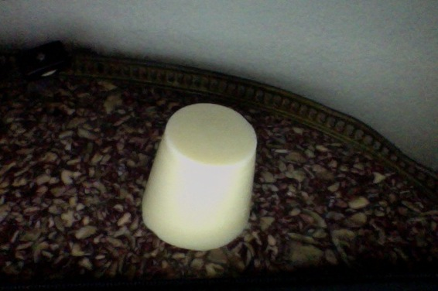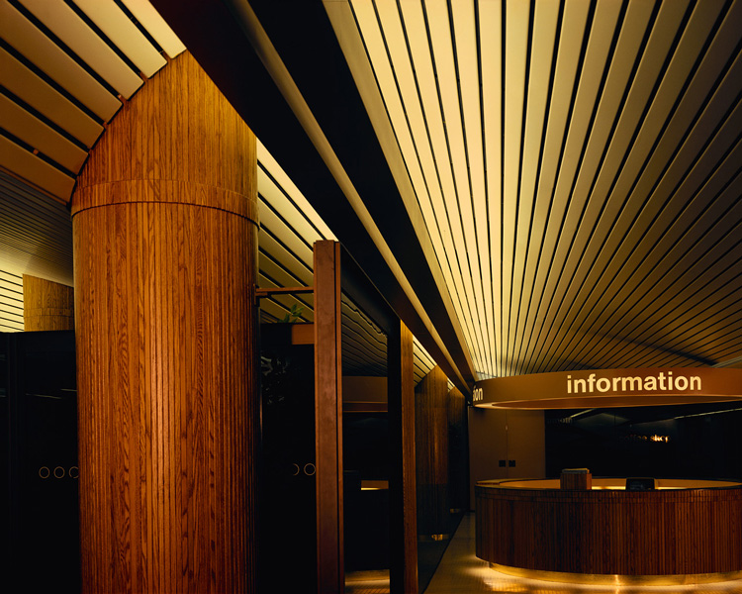

Contact Information:

15goulc@sagehillschool.org, 15jamnerd@sagehillschool.org, 15emtiazm@sagehillschool.org, 15rothb@sagehillschool.org

Ingredients:

Tropical Treasure Soap

Avocado Oil: 35g

Castor Oil: 25g

Cocoa Butter: 75g

Olive Oil: 75g

Palm Oil: 40g

Lye: 31.93g

Water: 80ml

Limited Edition

Avocado Oil: 25g

Canola Oil: 75g

Cocoa Butter: 50g

Grape seed Oil: 25g

Olive Oil: 50g

Palm Oil: 25g

Lye: 32.04g

Water: 80ml

Products: the Tropical Treasure (Left) & the Limited Edition Soap (Right)

For our soap, we chose a tropical theme.

SB & Co.